**Project Report Format**

1. **INTRODUCTION** 
   1. Project Overview
   2. Purpose
2. **LITERATURE SURVEY**
   1. Existing problem
   2. References
   3. Problem Statement Definition
3. **IDEATION & PROPOSED SOLUTION**
   1. Empathy Map Canvas
   2. Ideation & Brainstorming
   3. Proposed Solution
   4. Problem Solution fit
4. **REQUIREMENT ANALYSIS**
   1. Functional requirement
   2. Non-Functional requirements
5. **PROJECT DESIGN**
   1. Data Flow Diagrams
   2. Solution & Technical Architecture
   3. User Stories
6. **PROJECT PLANNING & SCHEDULING**
   1. Sprint Planning & Estimation
   2. Sprint Delivery Schedule
   3. Reports from JIRA
7. **CODING & SOLUTIONING (Explain the features added in the project along with code)**
   1. Feature 1
   2. Feature 2
   3. Database Schema (if Applicable)
8. **TESTING** 
   1. Test Cases
   2. User Acceptance Testing
9. **RESULTS**
   1. Performance Metrics
10. **ADVANTAGES & DISADVANTAGES**
11. **CONCLUSION**
12. **FUTURE SCOPE**
13. **APPENDIX**

**Introduction:**

**Project Overview :**

Sales analytics refers to the technology and processes used to gather sales data and gauge sales performance. Sales leaders use these metrics to set goals, improve internal processes, and forecast future sales and revenue more accurately.

The goal of sales analytics is always to simplify the information available to you. It should help you clearly understand your team’s performance, sales trends, and opportunities.

Generally, sales analytics is divided into four categories:

**Descriptive: What happened?**

Descriptive analytics entails tracking historical sales data—revenue, number of users, etc.—so you can make comparisons and better understand what’s currently happening.

**Descriptive: What happened?**

Descriptive analytics entails tracking historical sales data—revenue, number of users, etc.—so you can make comparisons and better understand what’s currently happening.

**Diagnostic: Why did it happen?**

Diagnostic analytics is examining and drilling down into the data to determine exactly why something occurred.

**Predictive: What’s going to happen?**

Predictive analytics is taking what you’ve learned about past sales and using it to gauge patterns and trends. This allows you to make educated predictions.

**Prescriptive: What’s the best solution or action?**

Prescriptive analytics involves assessing all the data and recommending the best plan of action.

**Purpose :**

Sales Analysis is the process of understanding how your business performs in terms of sales. It provides insights into the past, present, and future performance of a business and can be used to help you forecast trends, identify opportunities for growth, and develop a strategic action plan for your company.

**Literature Survey:**

**Existing Problem:**

* Sales reps have a hard time developing product or market specialization (unless the organization commits to specialized sales force allocated by geography).
* Many time it is hard forthe retailersto comprehend the market condition since their retail stores are at various geographical locations.
* Though firms are sometimes constrained in materials supply with inability to procure parts timely, the underlying ES technology provides the analytical and knowledgeleveraging support in managing their sales and customer service processes efficiently.
* The challenge for company marketing and sales reps in preparing forecasting is that internal bias is hard to avoid. Sales reps look better and tend to earn more commission when they achieve high sales Goals.

**References:**

* IBM Systems Journal.
* 2017 4th Asia-Pacific WorldCongress on Computer Science and Engineering.
* 2018 5th Asia-Pacific World Congress on Computer Science and Engineering (APWC on CSE).
* 2020 2nd International Conference on Information Technology and Computer Application (ITCA).

**Problem Statement Definition:**

* Sales professionals need to identify new sales prospects, and sales executives need to deploy the sales force against the sales accounts with the best potential for future revenue. We describe two analytics-based solutions developed within IBM to address these related issues. The Web-based tool On TARGET provides a set of analytical models to identify new sales opportunities at existing client accounts and noncustomer companies. The models estimate the probability of purchase at the product-brand level. They use training examples drawn from historical transactions and extract explanatory features from transactional data joined with company firmographic data (e.g., revenue and number of employees).
* Information technology in this 21st century is reaching the skies with large-scale of data to be processed and studied to make sense of data where the traditional approach is no more effective. Now, retailers need a 360-degree view of their consumers, without which, they can miss competitive edge of the market. Retailers have to create effective promotions and offers to meet its sales and marketing goals, otherwise they will forgo the major opportunities that the current market offers. Many times it is hard for the retailers to comprehend the market condition since their retailstores are at various geographical locations.
* To manage customer ordering and sales services efficiently, sales forecasting and operations planning as well as order intake and return material authorization processes must be responsive and nimble in an enterprise. Organizations have implemented enterprise systems (ESs) to integrate their supply chain operations such as receipt of customer orders, planning of production and shipping of goods. It evaluates the management of sales and customer service processes in manufacturing firms using an ES and its information. Three case studies are conducted in manufacturing companies that have implemented ESs to examine how these systems support the management practices and strategies in sales and service operations.
* Sales forecasting is a vital technology nowadays in the retail industry. With the help of advanced machine learning and deep learning algorithms, business owners can accurately predict the sales of thousands of products and make optimum decisions based onthem. It proposed a sales forecasting systembased on CatBoosting. The algorithm is trained on the Walmart sales dataset, by far the largest dataset in this field. We performed effective feature engineering to boost prediction accuracy and speed.

**Ideation & Proposed Solution:**

**Empathy Map:**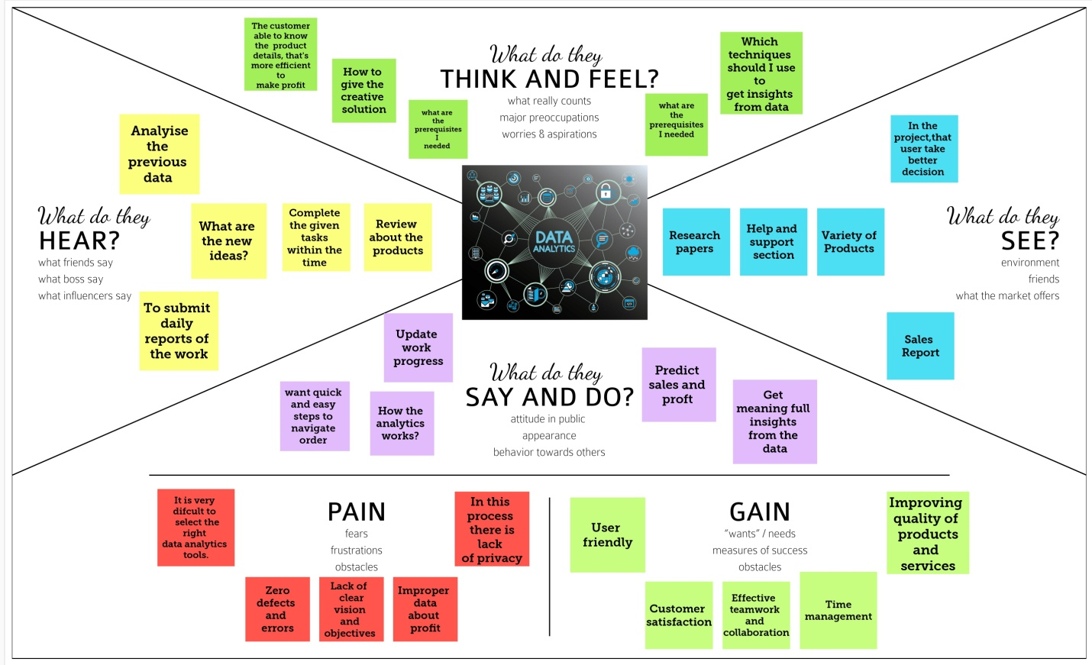

**Ideation and Brainstorming:**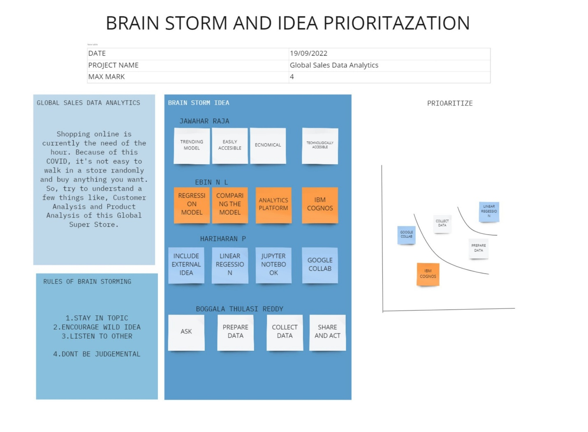

**Problem Statement and Proposed Solution:**

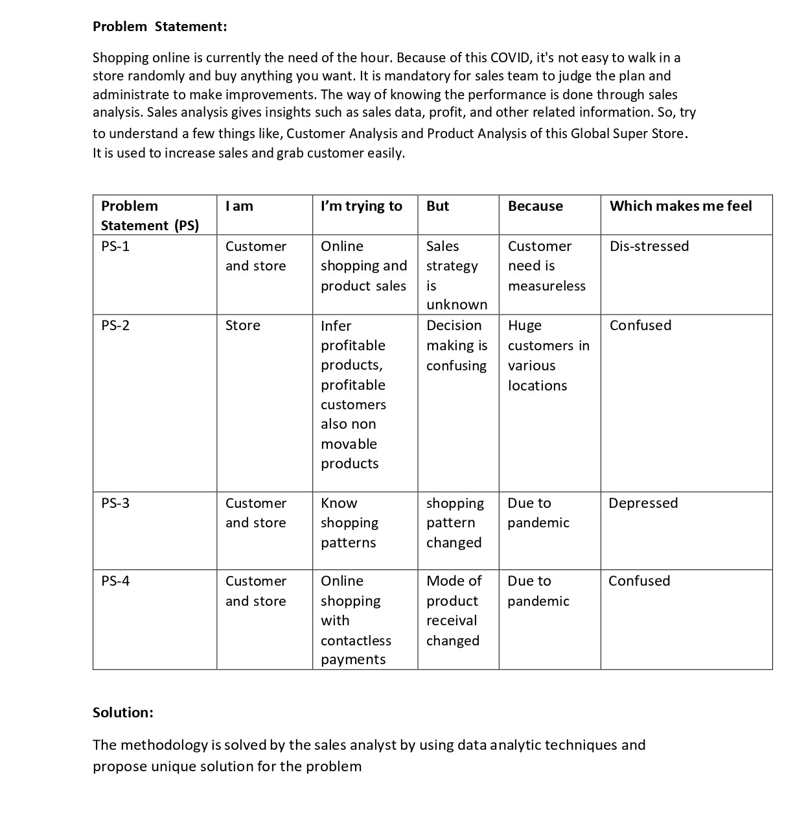

**Requirement Analysis:**

**Functional Requirements:**

Functional Requirements: Following are the functional requirements of the proposed solution. FR No. Functional Requirement (Epic) Sub Requirement (Story / Sub-Task)

FR-1 - Download the dataset Get the data from the given resource.

FR - 2 - Data pre processing Fill missing values, Remove duplicate values.

FR- 3 - Choose the tool for visualization IBM Cognos analytics is chosen.

FR- 4 - Data visualization Required graph, charts are chosen for visualization.

FR- 5 - Prepare dashboards Dashboards,story boards and reports are created in IBM Cognos analytics.

**Non - Functional Requirements:**

Following are the non-functional requirements of the proposed solution. FR No. Non-Functional Requirement Description

NFR-1 - Usability Itshould be easier to understand the insights for the customers.

NFR-2 - Security The data is protected from unauthorized access.

NFR-3 - Reliability Connecting the data to the software and further process.

NFR-4 - Performance The analysed information isrecorded and updated.

NFR-5 - Availability The tool is only available for the authorized persons to create, update, remove and the record customer information.

NFR-6 - Scalability Everyday activities are monitored for the growth of work. Analytic tool should support even the size of data is increased.

**Project Design:**

**Data Flow Diagram:**

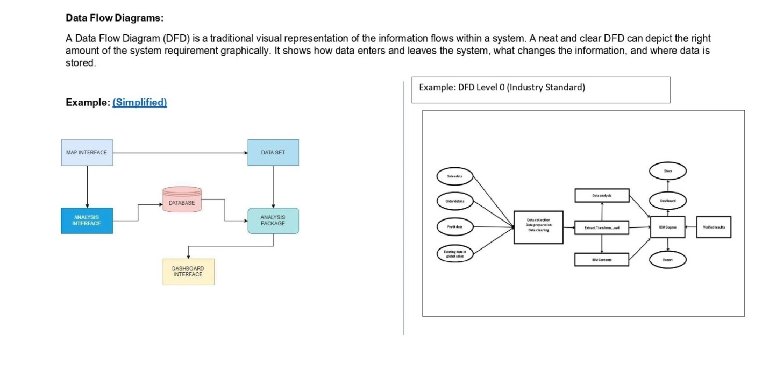

**User Stories:**

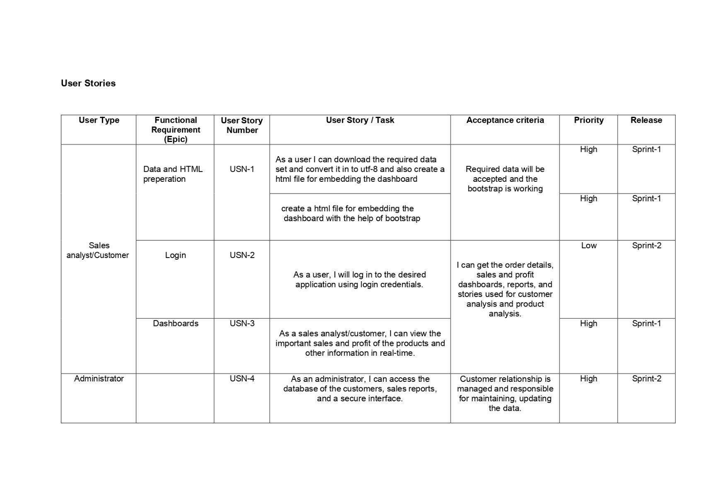

**Technical Architecture:**

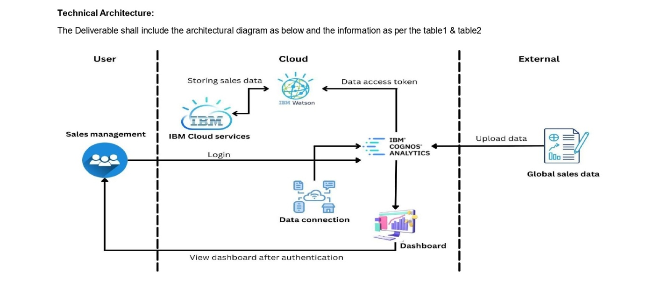

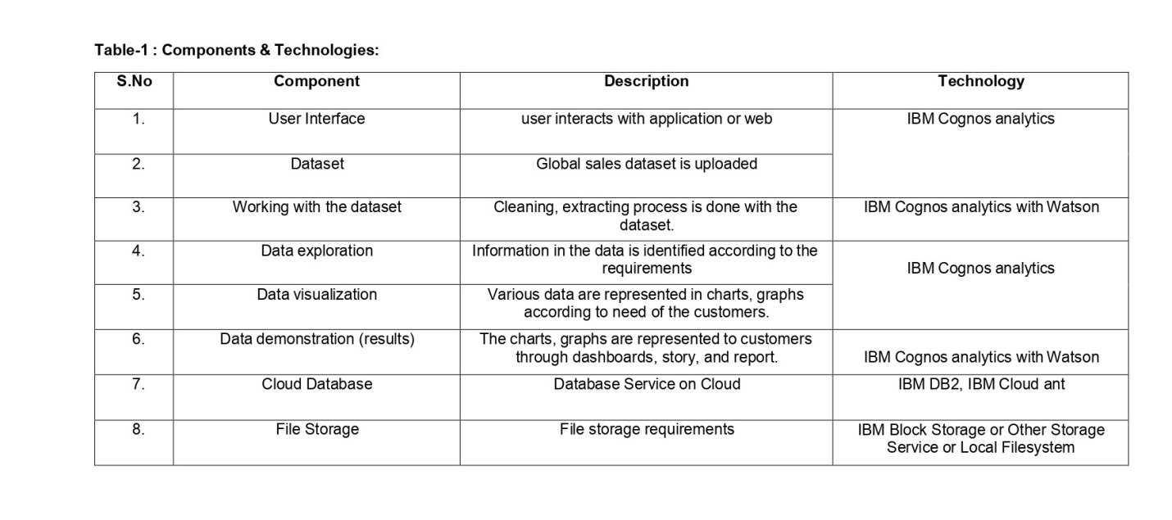

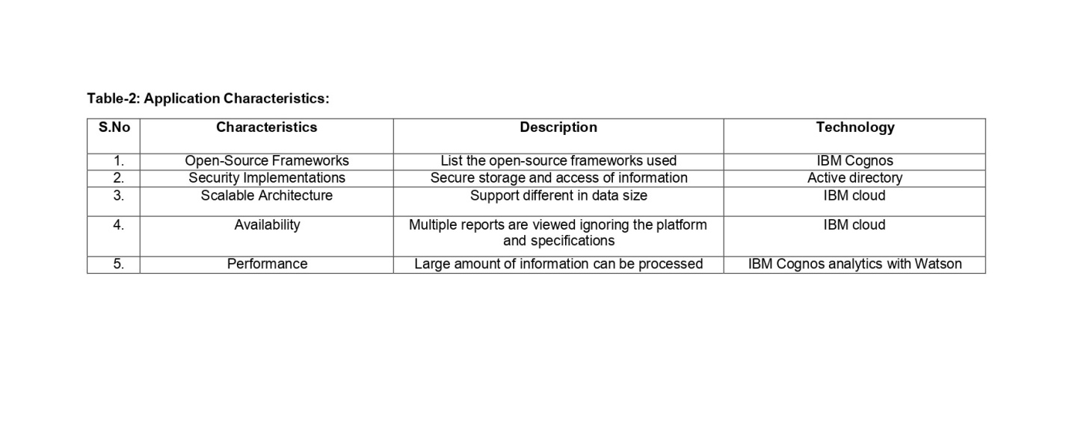

**Project Planning & Scheduling:**

**Sprint Planning and Estimation:**

|  |  |  |
| --- | --- | --- |
| **TITLE** | **DESCRIPTION** | **COMPLETED DATE** |
| **Literature Survey & Information Gathering** | Prepare Literature survey for the selected project & gathering information | 1 NOVEMBER 2022 |
| **Prepare Empathy Map** | Prepare Empathy Map Canvas to capture the user Pains & Gains, Prepare list of problem statements | 1 NOVEMBER 2022 |
| **Ideation** | List the by organizing the brainstorming session and prioritize the top 3 ideas based on the feasibility & importance. | 1 NOVEMBER 2022 |
| **Proposed Solution** | Prepare the proposed solution document, which includes the novelty, feasibility of idea, business model, social impact, scalability of solution, etc. | 7 NOVEMBER 2022 |
| **Problem Solution Fit** | Prepare problem - solution fit document. | 7 NOVEMBER 2022 |
| **Solution Architecture** | Prepare solution architecture document. | 7 NOVEMBER 2022 |
| **Customer Journey map** | Prepare the customer journey maps to understand the user interactions & experiences with the application (entry to  exit). | 7 NOVEMBER 2022 |
| **Functional Requirement** | Prepare the functional requirement document. | 7 NOVEMBER 2022 |
| **Data Flow Diagrams** | Draw the data flow diagrams and submit for review. | 7 NOVEMBER 2022 |
| **Technology Architecture** | Prepare the technology  architecture diagram. | 7 NOVEMBER 2022 |
| **Prepare Milestone & Activity List** | Prepare the milestones & activity list of the project. | 7 NOVEMBER 2022 |
| **Sprint delivery plan** | Prepare the sprint delivery plan of the project | 7 NOVEMBER 2022 |
| **Project Development - Delivery of Sprint-1** | Develop & submit the developed code by testing it. | IN DEVELOPMENT |
| **Project Development - Delivery of Sprint-2** | Develop & submit the developed code by testing it. | IN DEVELOPMENT |
| **Project Development - Delivery of Sprint-3** | Develop & submit the developed code by testing it. | IN DEVELOPMENT |
| **Project Development - Delivery of Sprint-4** | Develop & submit the developed code by testing it. | IN DEVELOPMENT |

**Sprint Delivery Planning:**

|  |  |  |  |  |  |  |
| --- | --- | --- | --- | --- | --- | --- |
| **Sprint** | **Functional Requirement (Epic)** | **User Story Number** | **User Story / Task** | **Story Points** | **Priority** | **Team Members** |
| Sprint-1 | Data and HTML preperation | USN-1 | As a user I can download the required data set and convert it in to utf-8 and also create a html file for embedding the dashboard | 2 | medium | EBIN N L JAWAHAR RAJA HARIHARA N P BOGGALA THULASI  REDDY |
| Sprint-2 | Pre processing | USN-4 | As a user, I can do the data cleaning process. | 2 | High | EBIN N L JAWAHAR RAJA HARIHARA N P BOGGALA  THULASI REDDY |
| USN-5 | As a user, I can perform Extract, Transform Load (ETL) process. | 2 | High |
| Sprint-3 | Dashboard | USN-6 | As a user, I can upload the data of global sales for analysis. | 1 | Medium | EBIN N L JAWAHAR RAJA HARIHARA N P BOGGALA  THULASI REDDY |
| Sprint-3 | Dashboard | USN-7 | As a user, I can analyse the data by performing calculations and executing several visualization charts. | 2 | High | EBIN N L JAWAHAR RAJA HARIHARA N P BOGGALA  THULASI REDDY |
| Sprint-3 |  | USN-8 | As a user, I can gain insights of the data for business analysis | 2 | High | EBIN N L JAWAHAR RAJA HARIHARA N P BOGGALA  THULASI REDDY |
| Sprint-3 |  | USN-9 | As a user, I can get the information for business analysis. | 1 | Medium | EBIN N L JAWAHAR RAJA HARIHARA N P BOGGALA  THULASI REDDY |
| Sprint-4 | Report, Story and customer care | USN-10 | As a user, I can generate report for the customer or sales analyst for knowing the insights about the sales. | 2 | Medium | EBIN N L JAWAHAR RAJA HARIHARA N P BOGGALA  THULASI REDDY |

**Reports from JIRA:**

|  |  |  |  |  |  |  |
| --- | --- | --- | --- | --- | --- | --- |
| **Sprint** | **Total Story Points** | **Duration** | **Sprint Start Date** | **Sprint End Date (Planned)** | **Story Points Completed (as on Planned End Date)** | **Sprint Release Date (Actual)** |
| Sprint-1 | 4 | 6 Days | 04 Nov 2022 | 10 Nov 2022 | 4 | 10 Nov 2022 |
| Sprint-2 | 4 | 6 Days | 05 Nov 2022 | 11 Nov 2022 | 4 | 11 Nov 2022 |
| Sprint-3 | 6 | 6 Days | 06 Nov 2022 | 12 Nov 2022 | 6 | 12 Nov 2022 |
| Sprint - 4 | 4 | 6 Days | 07 Nov 2022 | 13 Nov 2022 | 4 | 13 Nov 2022 |

**Advantages & Disadvantages:**

**Advantages:**

* Boost sales productivity. Sales reps need to always be on their toes to achieve results.
* Identify new sales opportunities.
* Plan effective sales targets.
* Improve customer acquisition.
* Incentivise sales teams.
* Increase customer retention.
* Market Research Analytics.
* Product Sales Analytics.

**Disadvantages:**

* Lack of alignment within teams. There is a lack of alignment between different teams or departments within an organization.
* Lack of commitment and patience.
* Low quality of data.
* Privacy concerns.
* Complexity & Bias.

**Conclusion:**

With the right data, sales success is far more achievable and, importantly, measurable. You just need to know how to analyze this data.

* Identify the key sales metrics you need, such as win rate and average deal size.
* Use a tool (such as Pipedrive’s CRM) to track this data as leads travel through your pipeline.
* Record this data in visual dashboards.
* Review the data regularly against historical averages to monitor growth and problem areas.

Sales data is enormously powerful and it’s something you come by just by tracking your activities effectively. Knowing how to fully utilize it will revolutionize your sales process, leading to better lead generation, client engagement and retention and, ultimately, more sales.

When coupled with the sales activities we’ve explored, you’ll have a cycle that provides you with refined data, revealing how you can save time and make money.

But remember, analyzing your data isn’t a one-time event; it’s a constant process. The sales industry doesn’t stay still for long and you’ll want to make sure your team has the best chance it can to beat the competition.